**CSS and CSS 3**

1. **What are the benefits of using CSS**?

* Solves a big problem
* Saves a lot of time
* Provide more attributes
* Better website speed
* Easier to maintain

1. **What are the disadvantages of CSS?**

* Confusion due to many CSS version
* Cross browser issues
* Limited security
* Extra work for developers

1. **What is the difference between CSS2 and CSS3?**

**CSS2:** CSS is capable for positioning texts and objects.

Responsive designing is not supported in CSS.

CSS is not split into modules.

CSS is very slow compared to CSS3.

CSS were developed in 1996.

**CSS3**: CSS3 is capable of making webpage more attractive and taking less

Time to crate.

CSS3 is latest version and hence it supports responsive design.

CSS3 can be breakdown in the modules.

CSS3 faster than CSS2.

CSS3 memory consumption is low than CSS2.

1. **Name a few CSS style components.**

Color:red;

Position:relative;

Text align:left;

1. **What do you understand by CSS opacity?**

The opacity describes the transparency-level, where 1 is not

Transparent at all, 0.5 is 50% see-through and 0 is completely

Transparent. When using the opacity property to add transparency to the

background of an element, all of its child elements become transparent as

well. This can make the text inside a fully transparent element hard to read.

If you do not want to apply opacity to child elements, use RGBA color values

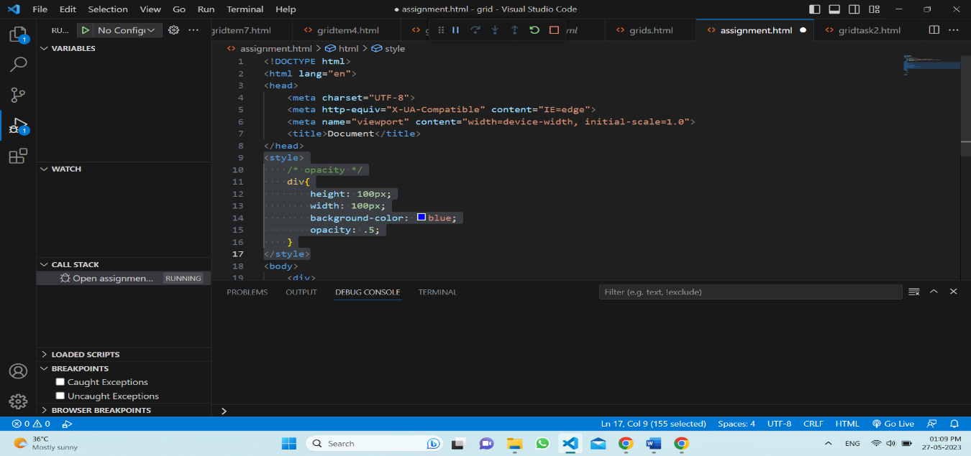 instead.

1. **How can the background color of an element be changed?**

Background-color;

Background-image;

Background-position;

Background (shorthand technique)

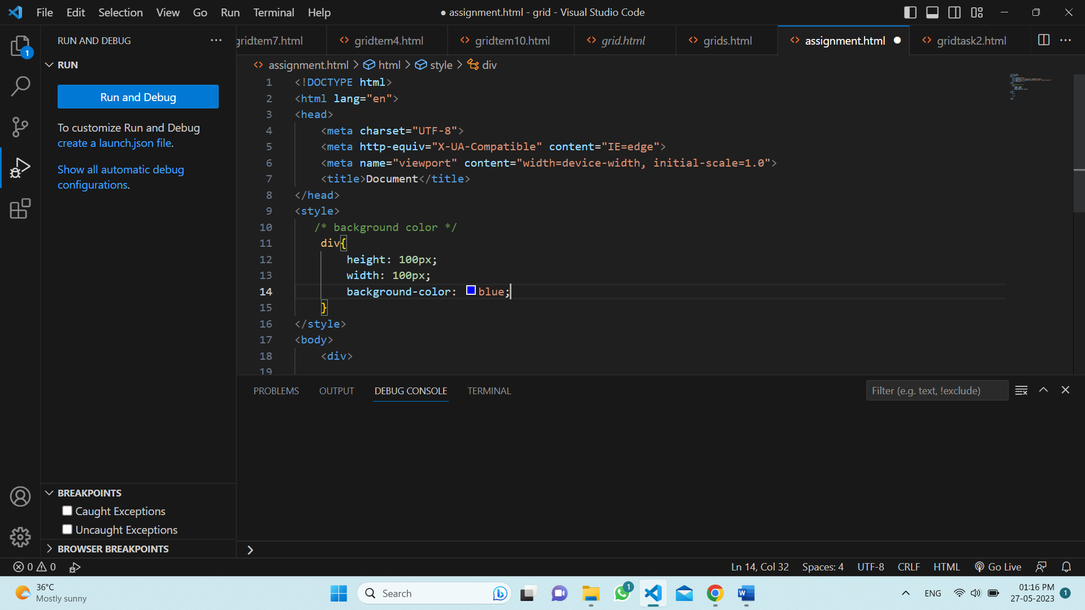

1. **How can image repetition of the backup be controlled?**

To control repetition of an image in the background, use the background-

Repeat property. You can use no repeat value for the background-repeat

Property.

Example:

Background-image:url(image.png)

Background-repeat:repeat;

Background-repeat:repeat-x;

Background-repeat:repeat-y;

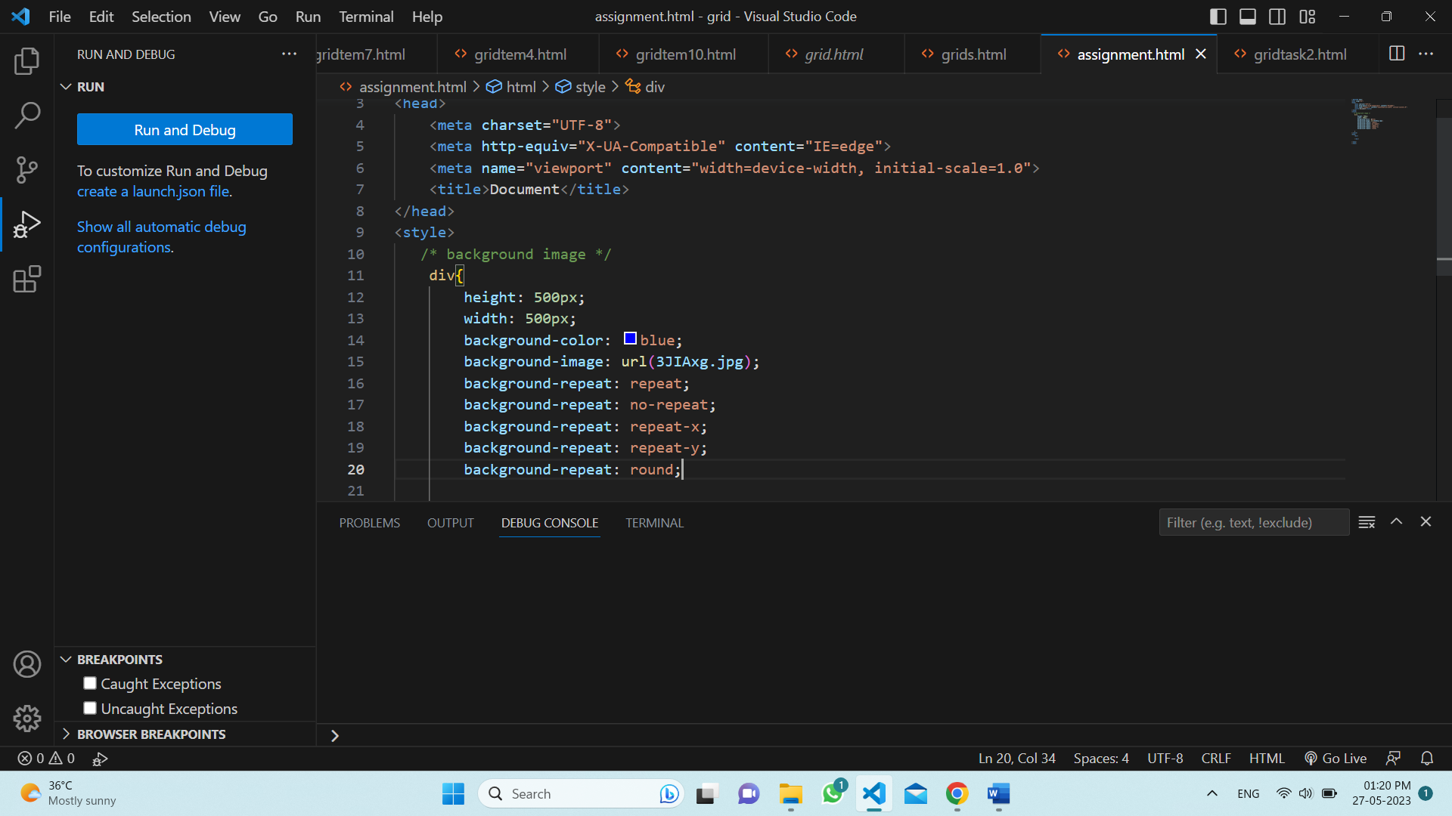

1. **What is the use of the background-position property?**

The background-position property sets the initial position for Background

Image.

List of value in property:

Top,bottom,center,left,right

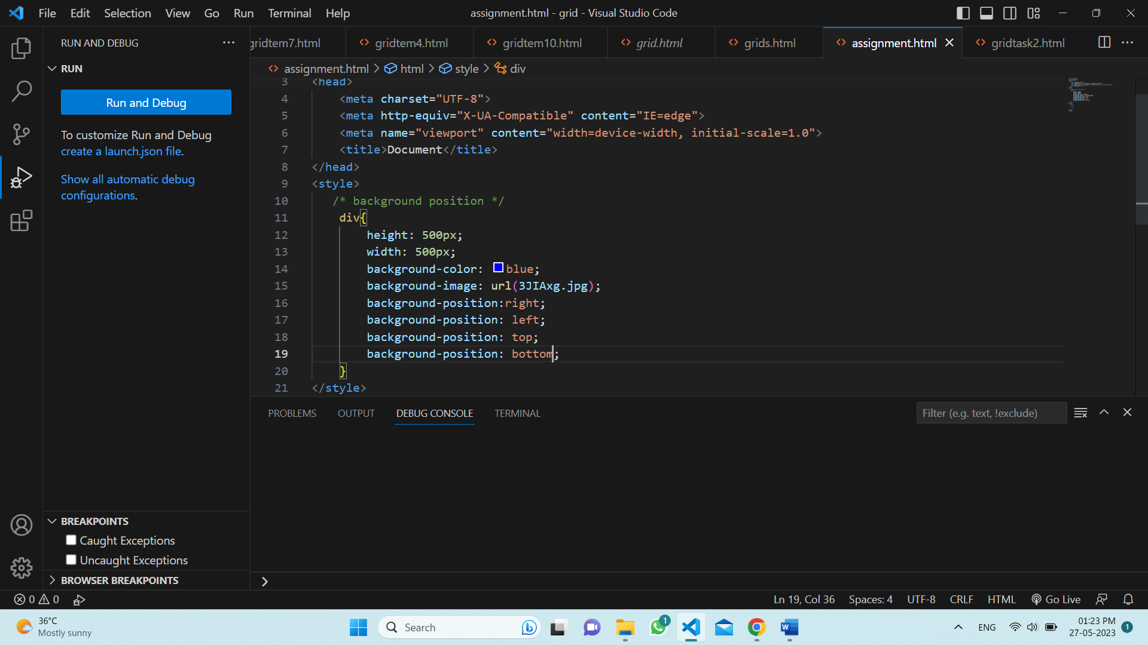

1. **Which property controls the image scroll in the background?**

The CSS property that controls the image scroll in the background is called background-attachment.

Background-attachment:fixed; this will control the image scroll.

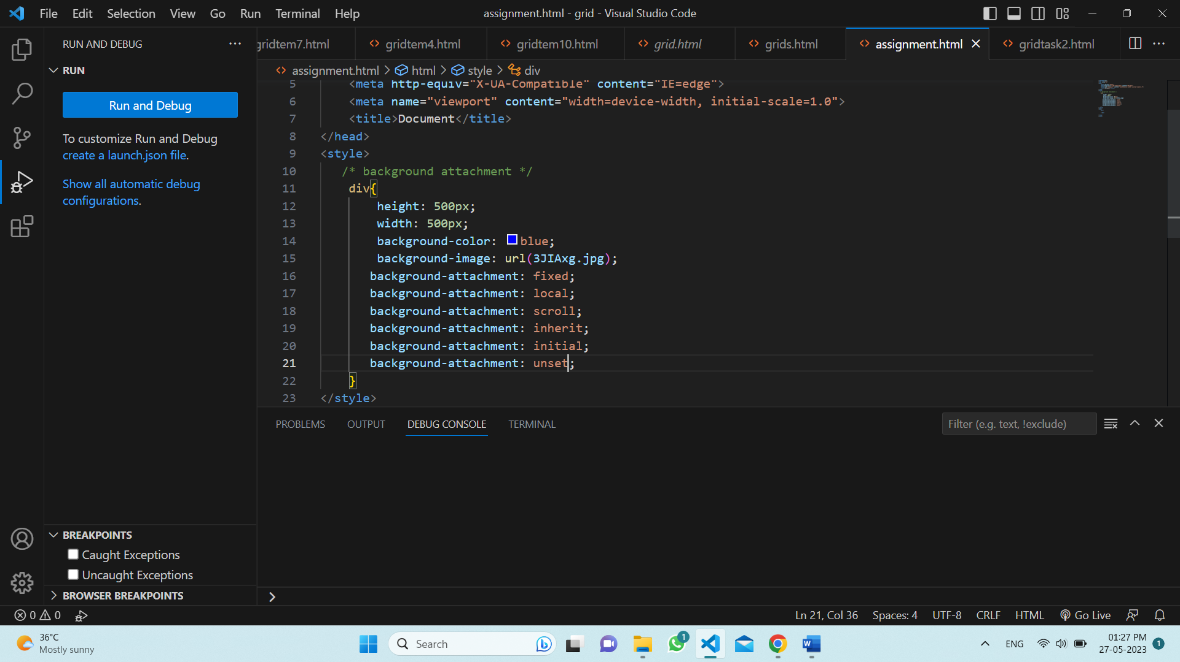

1. **Why should background and color be used as separate properties?**

The background property is a complex property in CSS , and if it is

Combined with color, the complexity will further increased.

1. **How to center block elements using CSS1?**

There are two ways of centering block level elements.

The properties margin-left and margin-right to auto and width to some explicit value.

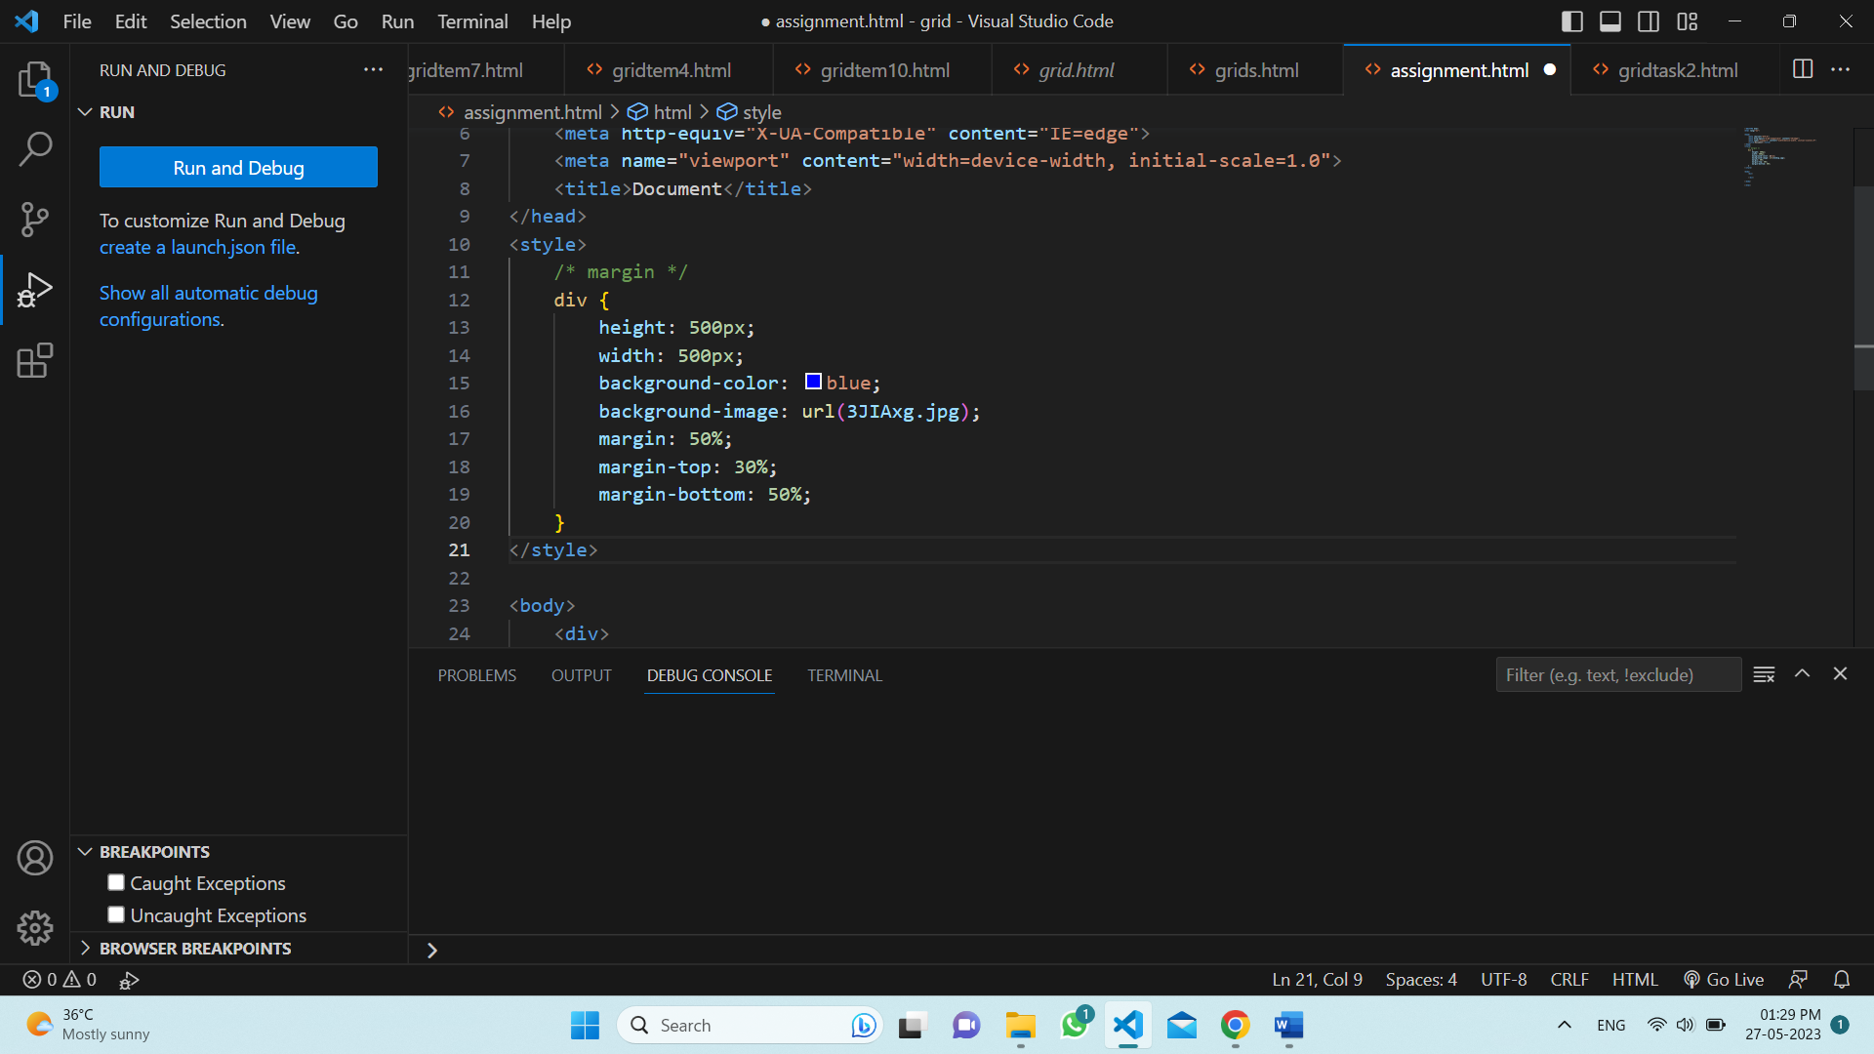

1. **How to maintain the CSS specifications?**

The CSS specification are maintained by World Wide Web.

The latest version of CSS is CSS3.

It makes easier to class and id special style code by CSS specification.

1. **What are the ways to integrate CSS as a web page?**

There are three ways to integrate CSS

* + - 1. Inline: inline style is directly defined by the html element using the style attribute
      2. Internal: internal style is defined the head section of an HTML. Document
      3. External: external style is create a new CSS file and the linked the HTML file.

1. **What is embedded style sheet?**

It allows you to define style for a particular HTML document as a whole in one place. This is done by embedding the <style> </style> tags containing the CSS properties in the head of your document.

Example:

<style>

#one{

Height:100px;

Width:100px;

}

</style>

1. **What are the external style sheet?**

External style sheets are crated in separate documents with a CSS extension.

External style is a create a new CSS file and the linked the HTML file.

Example:

<head>

<link rel=”stylesheet” href=”style.css”>

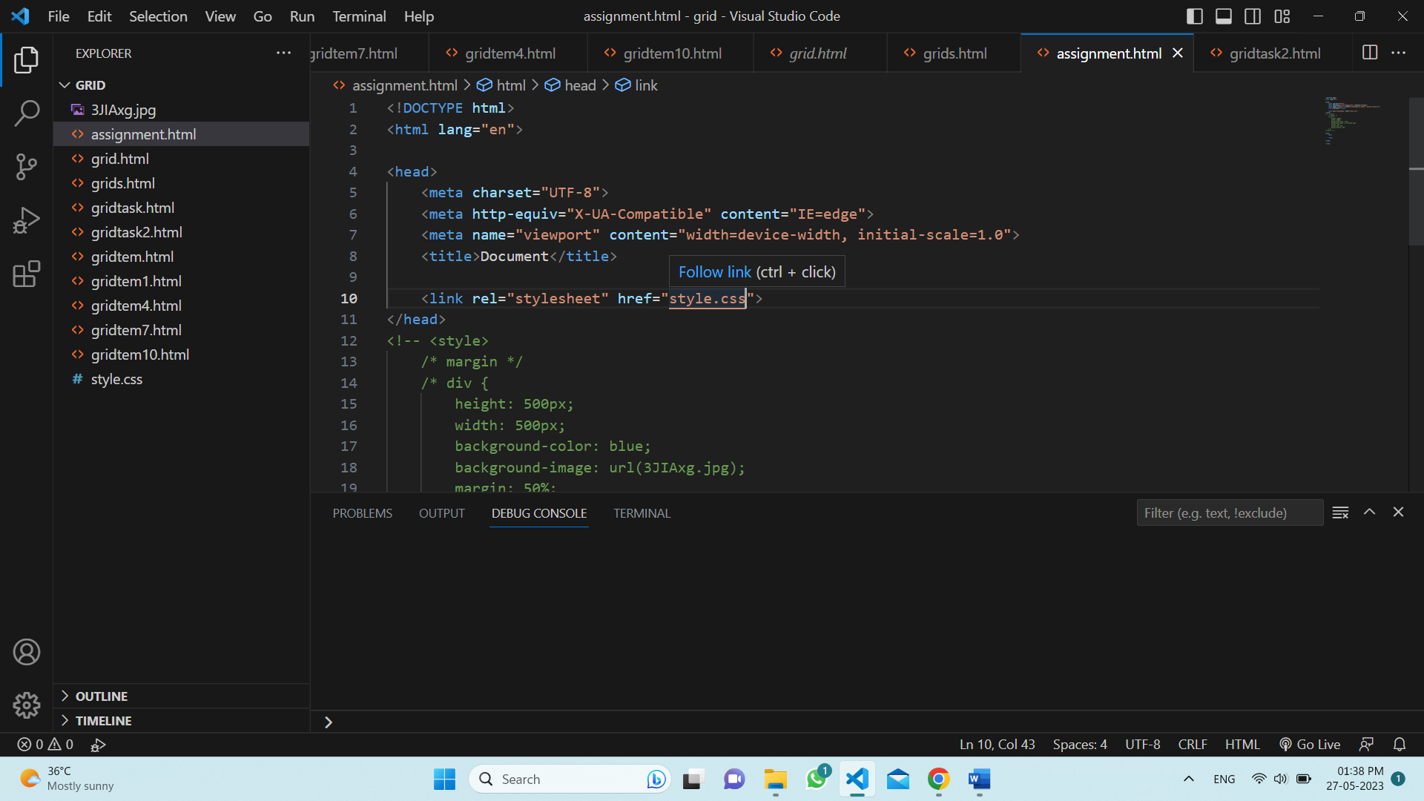

1. **What are the advantages and disadvantages of using external style sheets?**

Advantages:

The style of multiple documents can be controlled from one file.

Classes can be crated for use on multiple HTML element types in many documents.

Selector and grouping methods can be used to apply styles.

Disadvantages:

For style information for each document, an extra download is needed.

Until the external style sheet is loaded, it may not be possible to render the document.

1. **What is the meaning of the CSS selector?**

CSS selectors select HTML elements such as: id,class,attribute,type,etc.

There are five types of selectors:

Element selector:

Syntax:

P{color:green}

Id selector:

Syntax:

#p{color:violet}

Class selector:

Syntax:

.p{color:red}

Universal selector:

Syntax:

*{color:blue}

Group selector:

Syntax:

P,h1{color:green}

1. **What are the media types allowed by CSS?**

List of media types:

All

Print

Speech

Screen

Handheld

Tv

1. **What is the rule set?**

A rule set is a attachment that tells browsers how to render particular elements on an HTML page. A rule set consists of a selector followed by a declaration block.

We can use the selector name and then declare it using different properties.

We can use one or more selectors in our CSS code and use multiple properties along with their values in the declaration part.